Directorial Features of the Elements of Peking opera used in Animation

JiaNi Zhou, MinSik Hwang, HyunSeok Lee

Dept of Visual Contents
Graduate School of Dong-Seo University
Busan, South Korea
moses472530@gmail.com
hslee@gdsu.dongseo.ac.kr

Abstract

Peking opera is a traditional form of art which conveys Chinese history and sentiments. Although there has been an abundance of research on Chinese traditional arts used in animation, research has been limited on the use of Peking opera. This study examines the features of animation which draws elements from traditional Peking opera. First, pilot study addresses the features of traditional Chinese animation and Peking opera. Second, 3 tangible elements and 3 intangible elements of Peking opera are identified. Third, case study examined two animation films, <The Proud General (骄傲的将军), 1956> and <Havoc in Heaven (大闹天宫), 1964>, which use elements of Peking opera. As a result, it is shown that the traditional elements of Peking opera are used in animation to produce novel directorial features. This study highlights how the traditional Chinese art of Peking opera is used in animation to enhance artistic and directorial functions.

Keywords: traditional Peking opera, China Animation, Direction Feature

I. Introduction

Peking opera, a traditional Chinese artistic theatre, conveys Chinese sentiments; its artistic merit has meant that Peking opera has often made its way into modern media to produce hybrid works of cinema, drama and animation. Particularly in the animation genre, the very first long animation film produced in China, <Princess Iron Fan (鐵扇公主), 1941>, used elements of traditional Peking opera; it is not difficult to see that the elements of Peking opera hold the traditional values of Chinese art. As such, there have been active researches on animation which adopt elements of Peking opera; but research has been limited on their directorial features. Thus this study purports to examine the elements of Peking opera in animation to identify their directorial characteristics.

II. Traditional Chinese animation and the elements of Peking opera

Lee (2004) argued that ‘Peking opera is a traditional Chinese theatre which has the most profound influence of all Chinese cultural productions.’ [1] Peking opera has been continuously produced and developed since its origin in Qing dynasty around 1790. In recent times, Mei Lanfang (梅蘭芳) was highly popular. It is also widely known abroad, praised for its unique artistic merit.

A. Origin of traditional Chinese Animation

Kim & Kim (2009) argued that Chinese animation from its inception has expressed strong national cultural characteristics not only in characters but also in production method, subject matter and contents. [2] The first Chinese animation was produced by ‘Man brothers’ in Shanghai in 1926; it was a silent black-and-white short animation film called <Noisy Studio, 1926> as shown in Fig. 1. Left). From that work, Chinese animators have long produced animations which convey the traditional Chinese aesthetics. In 1958, paper cut-out, a traditional Chinese folk art form, was combined with shadow play to produce the first cut-out animation <Zhu Bajie eats watermelon, 1958>. Ahn (2013) comments on the debut of the animation director Te Wei as Chinese animation ‘leaving the period of passive imitation of foreign works and entering a period of autonomous creation.’ [3]

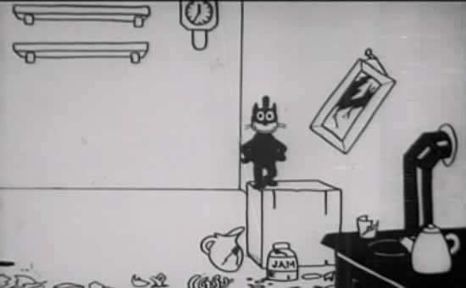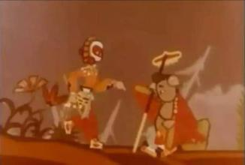

Fig. 1. Left) <Noisy Studio, 1926>, Right) <Zhu Bajie eats watermelon, 1958>

Thus the development of Chinese animation has been on a basis of traditional Chinese art; animation which adopts the elements of traditional Peking opera is one such example. The following case study examines Chinese animation films which adopt elements of Peking opera that convey the Chinese tradition.

B.Peking opera as a Traditional Chinese Composite Art Form

Cha (2013) saw Peking opera as a ‘composite art form consisting of diverse elements’ [4]; indeed, Peking opera consists of various elements. Jang (2011) pointed out that ‘makeup in Peking opera is an important way of communication which aids the audience’s understanding of the role of characters.’ [5] Makeup in Peking opera is character-specific in a way that the audience sees the style and
colours of makeup to intuitively recognise the personality, status and dramatic role of different characters. Just like makeup, props form an important element of Peking opera; props in Peking opera are exaggerated, artistic versions of real objects. Actors use props to expand their expressive space while adding detail and dramatic impact to the stage.
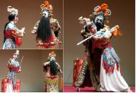

Fig. 2. Three scenes from Peking opera

Lee (2014) thought that ‘Peking opera, with singing and dancing as a major means of direction, uses the actors’ movement as a way of expression,’ [1] pointing to the importance of movement, as in dance and martial arts. Indeed, standardized movement design is a key element of Peking opera. This is called ‘formalization’ (程式化) which refines, exaggerates and distorts everyday language and movement. Through this the movement of Peking opera takes on a new artistic expression and assumes Peking opera’s characteristic aesthetics. For musical accompaniment, percussions instruments like cymbals, drums, pan and jeon are mainly used; these are all expressive and adoptive instruments. These instruments come into harmony to express various emotions, atmospheres and artistic sentiments. Usually, taepyongso, cymbals and drums are used to express celebration and passion; softer instruments like tungso, jaeng and flutes are used to express melancholy or the delicate air of broad sky.

C. Case Study

C.a.Analysis Standards and Case Selection

Based on the preceding pilot study and Cha’s study (2013) on the elements of Peking opera, the following elements have been identified; for tangible elements, makeup, costume and props; for intangible elements, instrumental music, singing and movement. These 6 elements will serve as analysis standards for case study. [6] Two Chinese animation films which clearly show the elements of Peking opera have been selected for case study, as shown in the table below.

TABLE I
CASE STUDY WORKS

Title | Length | Director | Year
The Proud General | 24" | Te Wei  Lee Geukyak | 1956
Havoc in Heaven | 1'44" | Wan Laiming | 1964
C.b.Case Analysis

C.b.a. <The Proud General (骄傲的将军), 1956>

<The Proud General, 1956> was the first animation to adopt the elements of Peking opera to showcase traditional Chinese characteristics. For instance, the face of the general takes the ‘daehwagum’ makeup which represents a generous man in Peking opera; the facial shape is narrow at the top and very wide in the chin. The ‘daehwagum’ makeup shows a typical Peking opera style, white going from nose to forehead and chin, with blue grey around the eyes and dark pink on cheeks. Bold eyebrows and big moustache depict strong, tough and imposing character of a general.

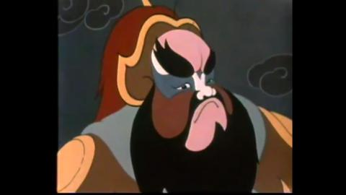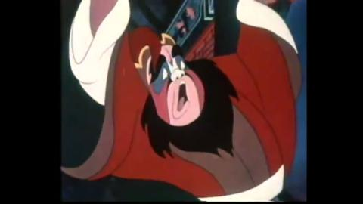

Fig. 3. Two scense from <The Proud General (骄傲的将军), 1956>

The general’s entrance movement takes from that in Peking opera. He walks with his chin high up, chest out, in big strides to the beat of cymbals and rums, repeating walking and stopping. The general also listens to sycophantic comments from his people, holding a cup with one hand and caressing his moustache with the other to represent an imposing character. These are all characteristic gestures from Peking opera. Also, when throwing cooper pots and exerting his force, he sounds the characteristic overture sound from Peking opera in a rather exaggerating manner to recreate the feel of traditional theater.

C.b.b. <Havoc in Heaven (大闹天宫), 1964>

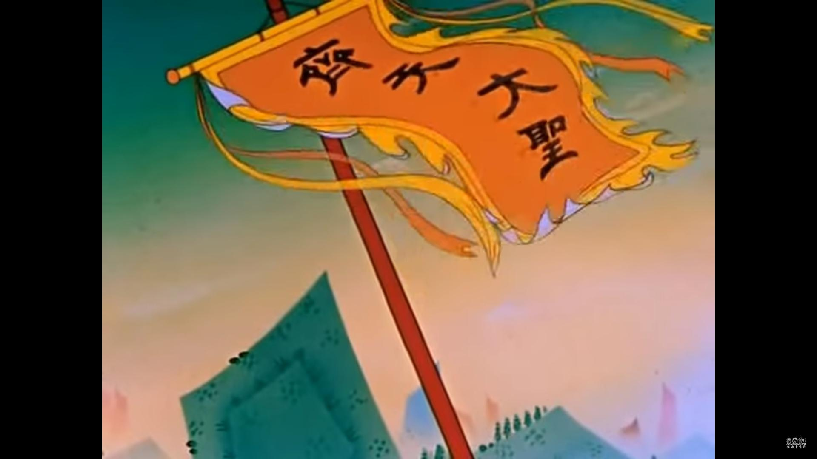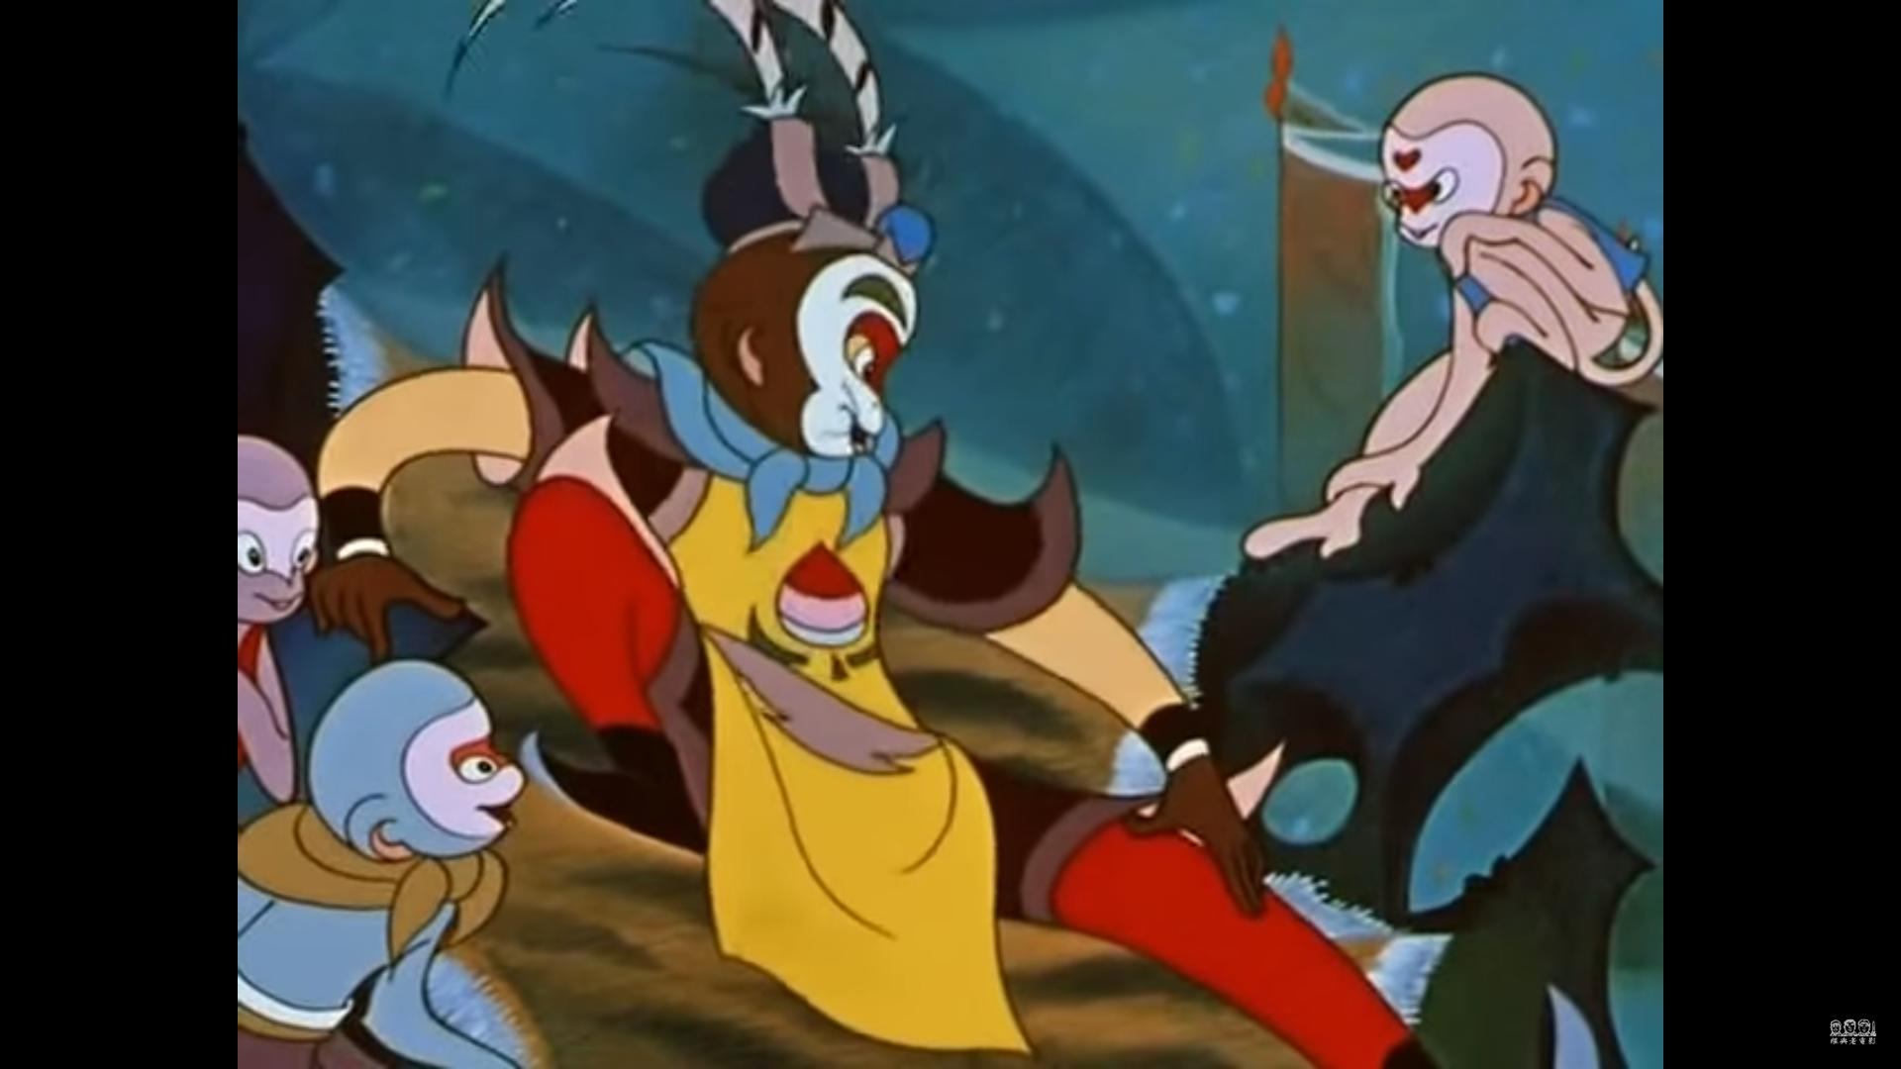

Fig. 4. Two scenes from <Havoc in Heaven (大闹天宫), 1964>

<Havoc in Heaven, 1964> was based on the ancient Chinese novel <Journey to the West>. In the animation, the scene where Son Wukong runs into the heavenly palace to cause a havoc is recreated. Son’s face in animation retains the Peking opera makeup of white background with simplified red peach-shaped lines and patterns, highlighting yellow eyes and curves on the cheeks; eye brows are coloured green to express the dynamic character of Son Wukong who calls himself the great master of skies. Son repeats a pattern of moving and stopping to the beat of cymbals and drums; this again draws from the traditional entrance movement in Peking opera. Also, all actions in the film take their motif from actions in Peking opera, with the addition of the characteristic cymbals and drum sound. When Son Wukong is dubbed ‘jecheondaesung,’ his act of putting a feather in his head and stroking it is from the formal action of Peking opera.
The use of Peking opera music in the fight scene in <Havoc in Heaven, 1964> added to the dramatic tension of the film, enhancing the visual rhythm of the scene. The solemn sound of cymbals, drums and cheerful tungso flute expresses the majesty of Son Wukong upon entrance. This later turns into cymbals and drums, with tempo increasing; to the characteristic ‘chan-chan’ sound, Son Wukong comes tumbling to fast rhythm. When Son Wukgong handles a sword, cymbals and drums repeat in intervals to mimic Son’s movement.

C.c. Summary

As the result of case study shows, Peking opera animation adopts elements of Peking opera. Tangle and intangible elements made difference in such adoption, as shown in the table below.

TABLE II
SUMMARY

Category | Element | Expressions | Descrpition
Intangible | instrument | Traditional instrument | adopted without change
Intangible | Song | song, lyrics | adopted without change
Intangible | Movement | Gesture, martial arts | adopted without change
Traditional | Makeup | makeup | adopted with exaggeration, distortion
Traditional | Costume | clothing | adopted with exaggeration, distortion
Traditional | Props | tools, flags | adopted with exaggeration, distortion

III. Conclusion & Recommendation

This study began with a pilot study of traditional Chinese animation and the features of Peking opera in order to examine the traditional artistic characteristics of Chinese animation. Then the elements of Peking opera. Based on this, two animations with the elements of Peking opera were examined. This showed that the traditional elements of Peking opera are used in animation to portray national characters and aesthetics. Also, it was found that tangible and intangible elements of Peking opera are adopted in different ways. It is hope that this study makes a meaningful contribution to the continued production of hybrid works which combine traditional Chinese arts with modern technology, while serving also as a point of reference for future studies.

References

[1] Lee, Youngsuk, A Study on the Aesthetic Characters of Peking opera, Future Creation Institute, Seowon University, 1(4), 95p, 2004.
- Kim, Jinyoung, Kim, Jaewoong, A Study of National Cultural Character in Chinese Animation, Cartoon & Animations Studies, p83-95, 2009.
- Ahn, Youngeun, Beijing Olympics and Chinese Culture Code, Global Cultural Contents, pp. 31-52, 2013.
- Cha, Mikyung, From 『SagiHangwubongi』to <Farewell My Concubine>. Chinese Cultural Studies Society, 23, 144p, 2013.
- 蒋丽丽, 京剧元素在动画造型中的运用, 商业文化, 342p, 2011.

